Consider an input image of size 1000×1000×10 where 10 refers to the number of channels (Such images do exist!). Suppose we want to apply a convolution operation on the entire image by sliding a kernel of size 1×1×d What should be the depth d of the kernel?

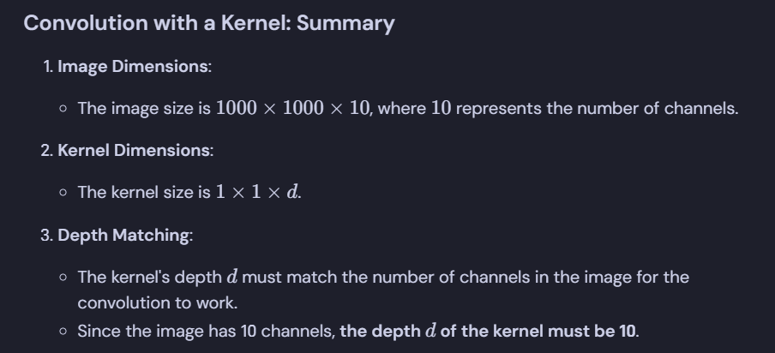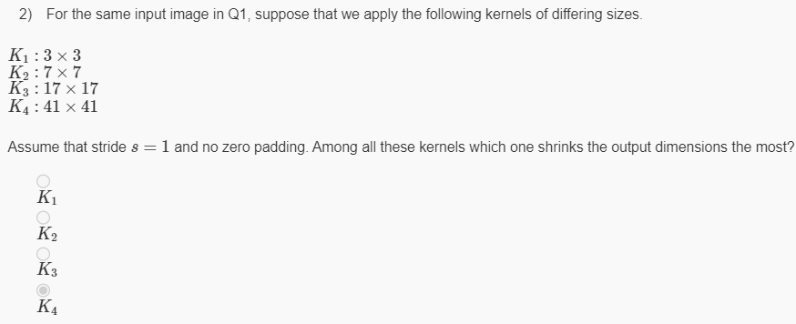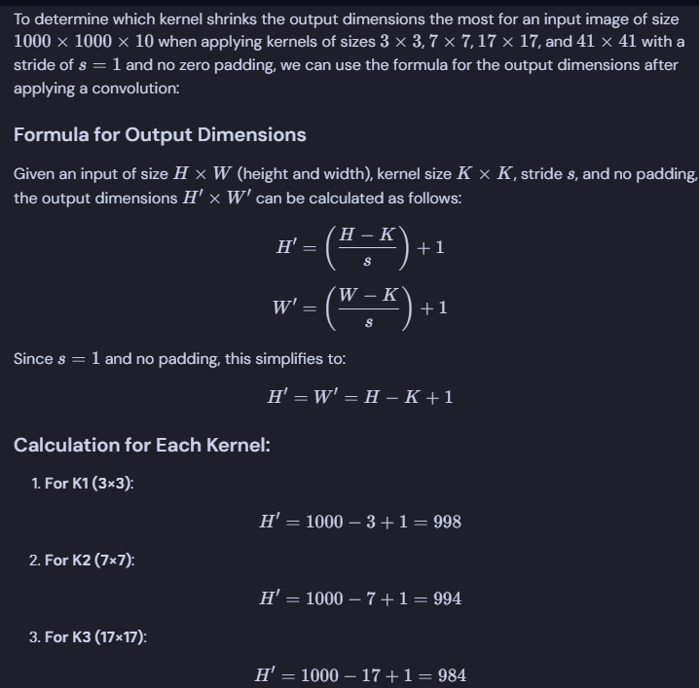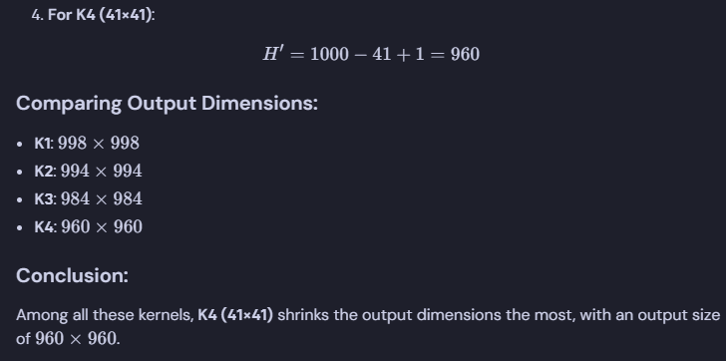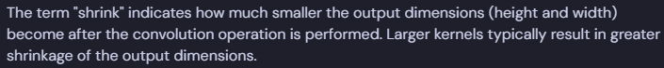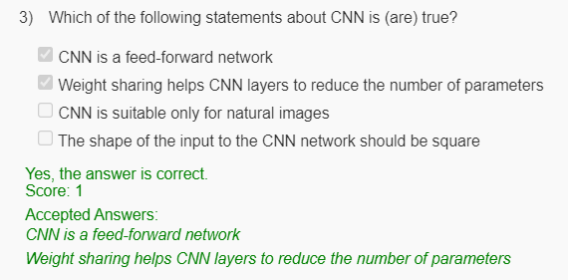

Consider an input image of size 100×100×3. Suppose that we used kernel of size 3×3, zero padding P=1and stride value S=2. What will be the output dimension?

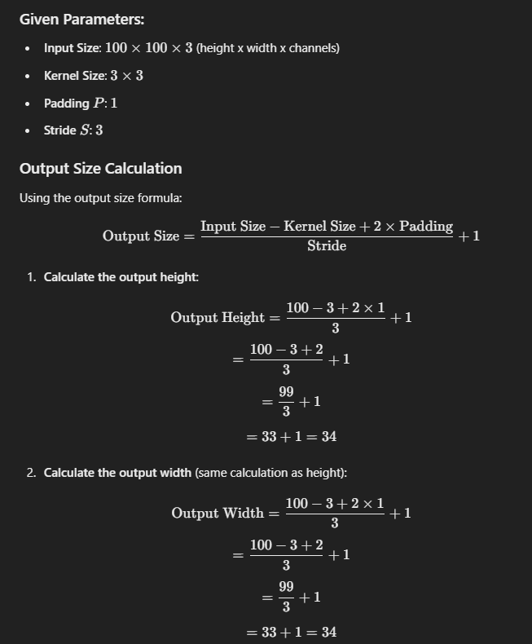 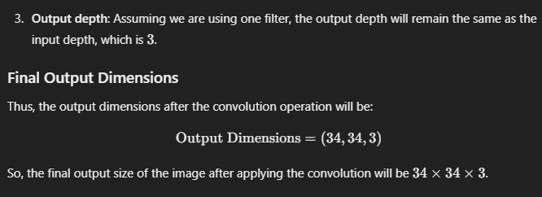 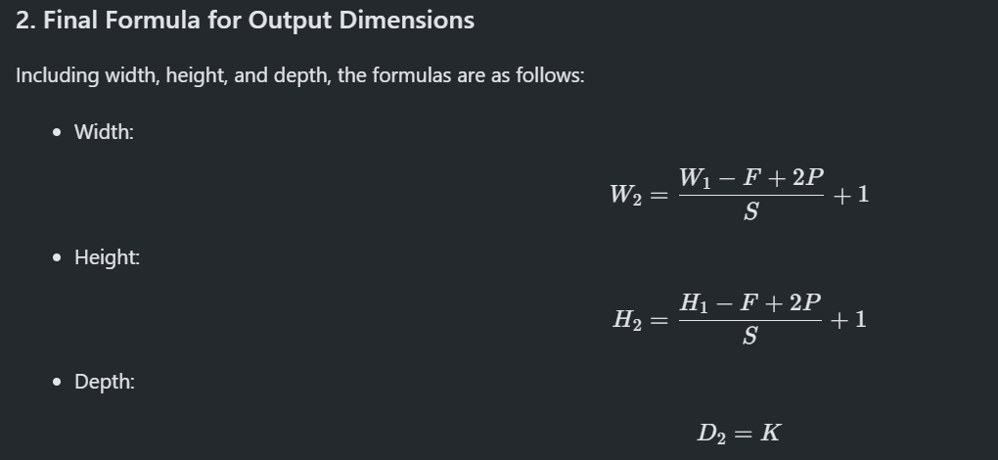

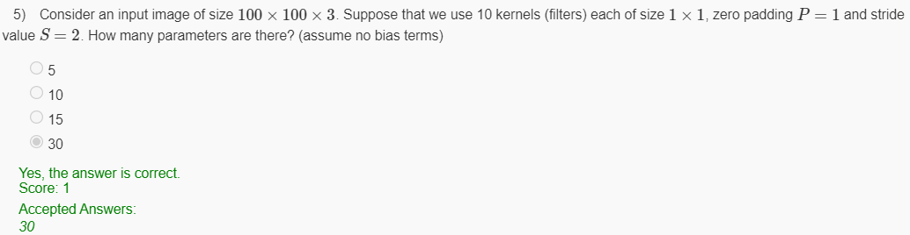 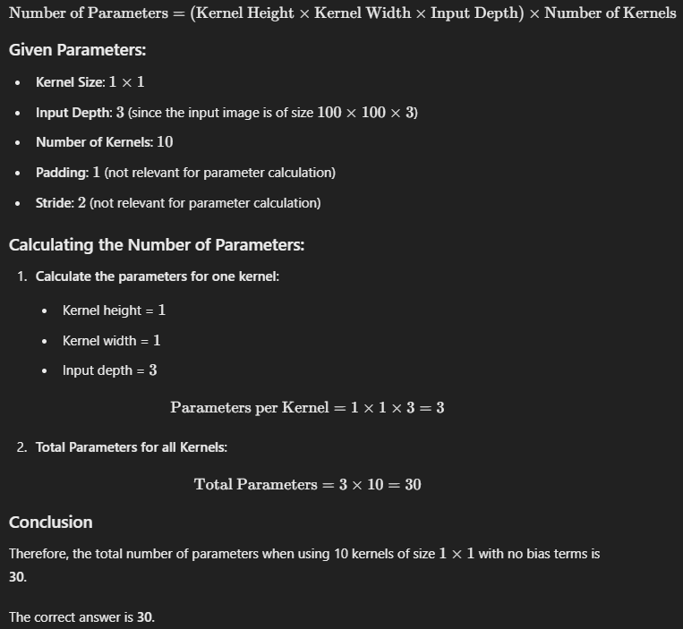

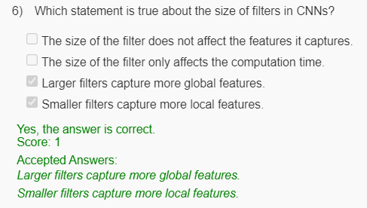 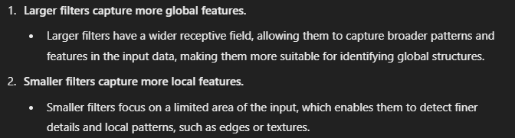 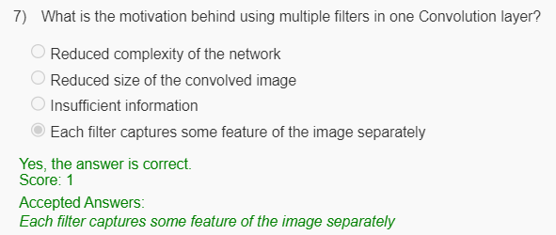

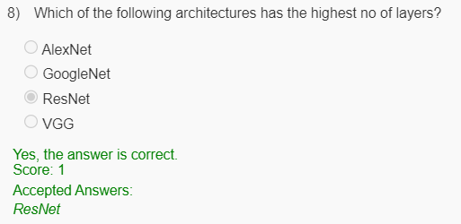 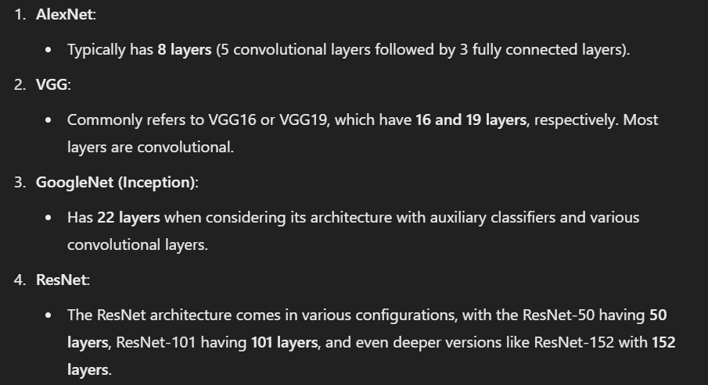 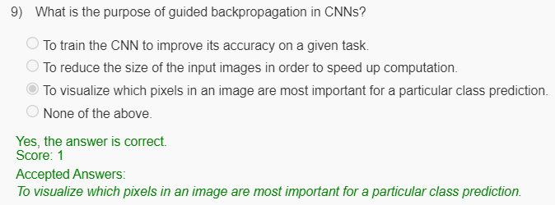

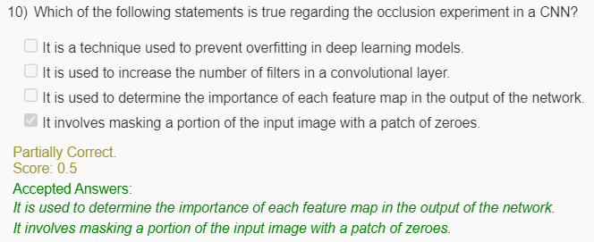 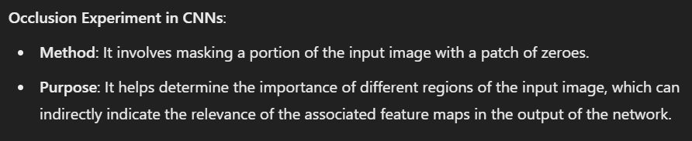

Consider the following:

* Weight array, W = [0.2, 0.7, 0.05, 0.75, 0.86, 0.21]
* Input X = [0.1, 0.2, 0.3, 0.4, 0.5, 0.6, 0.7, 0.8, 0.9]

What is the next revised estimate S that is obtained by sliding the filter W over the input X?

**Note:** Include two digits after the decimal.

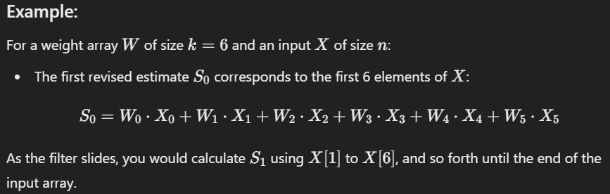

Here only asked next st means S1 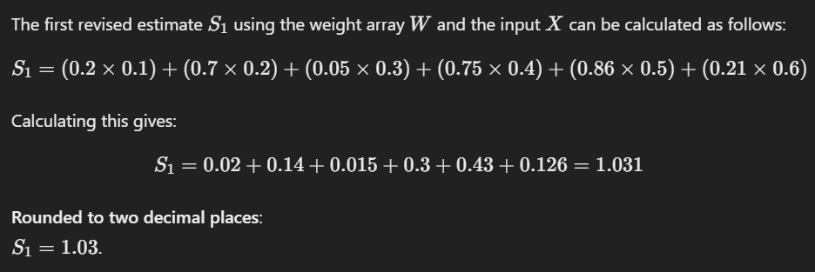  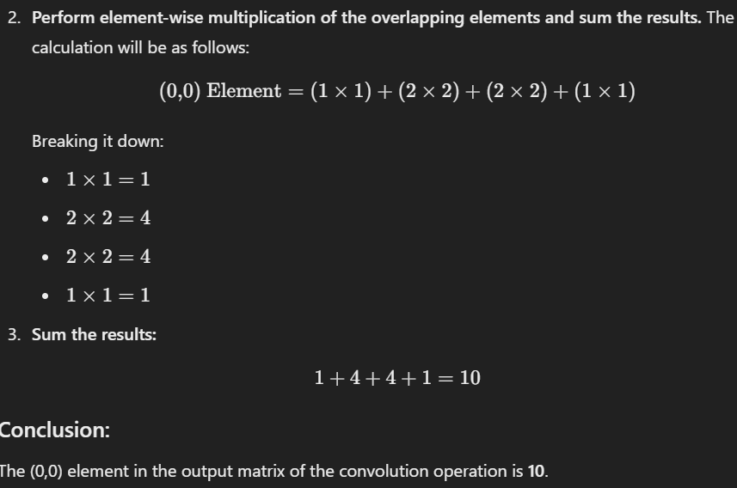 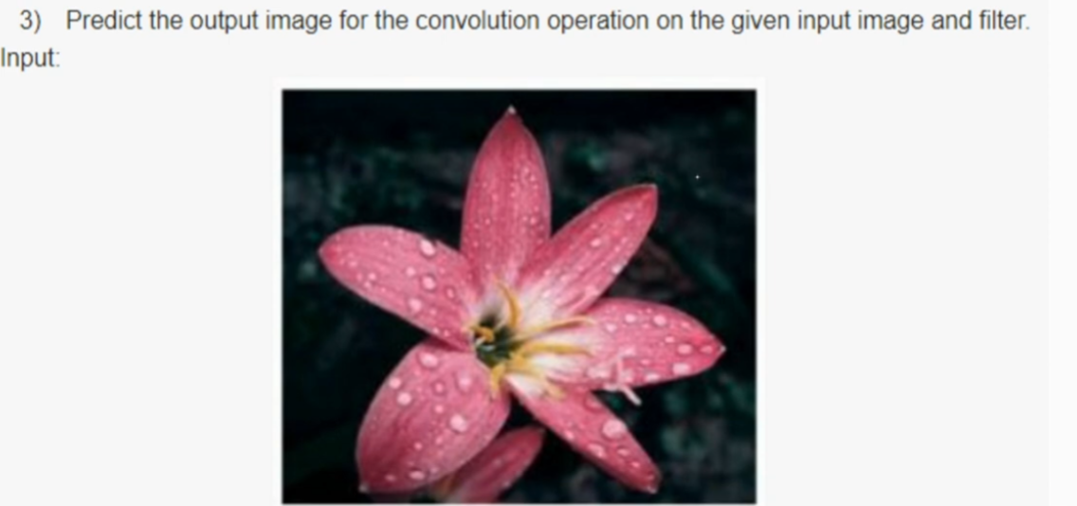 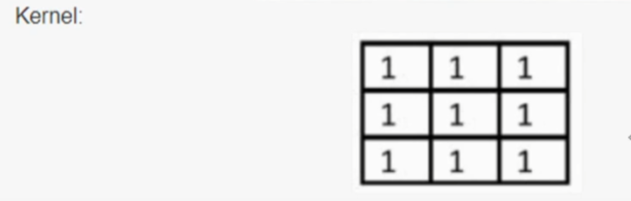 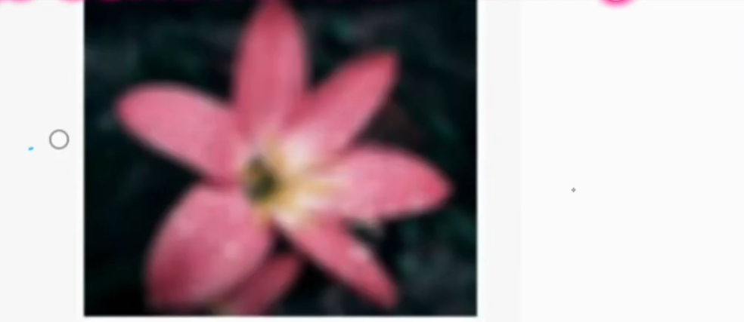 

Consider a 2D filter convolution over a 3D input. What would be the dimension of the output?

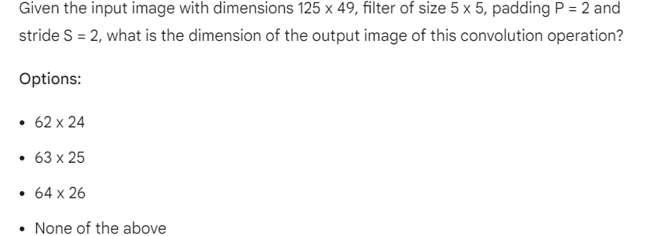 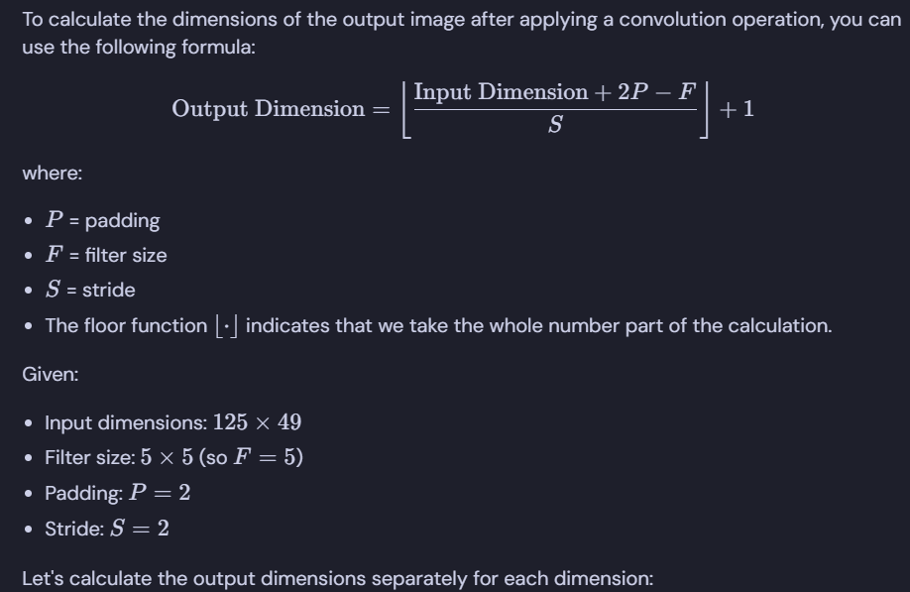 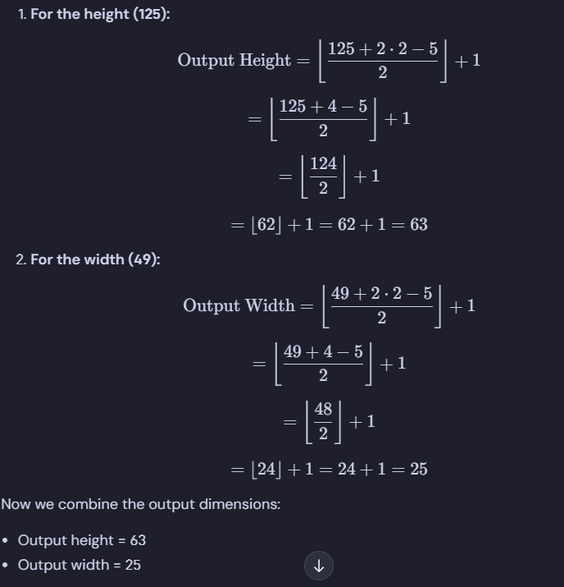 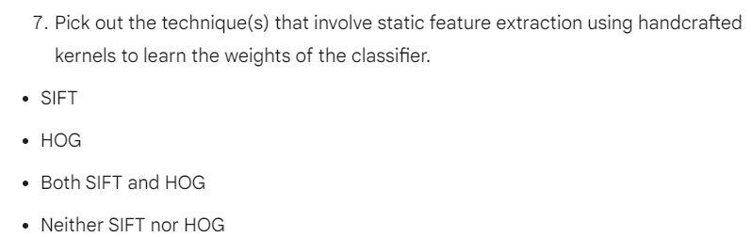 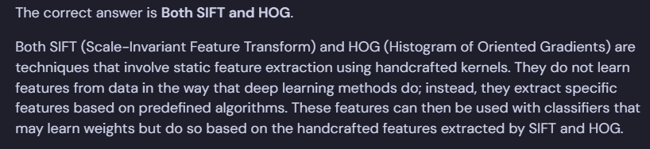 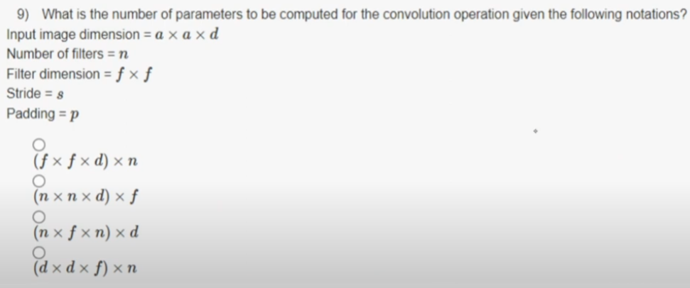

1. Given the stride rate 1, compute the output for the Average pooling operation on the given input matrix.

3 7 6 4

2 6 4 8

1 8 5 2

1 9 7 5

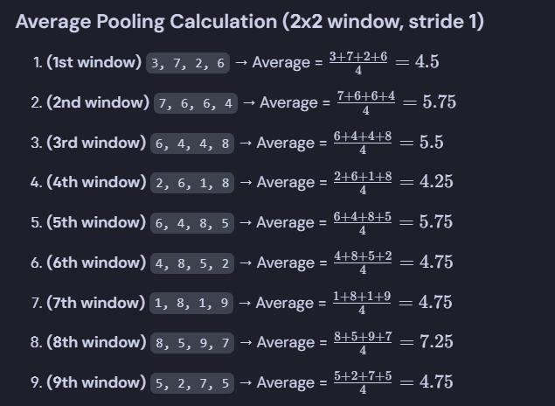 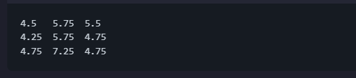

The question is:

1. What is the number of parameters to be computed for the convolution operation given the following notations?

Notations:

* Input image dimension = a x a x d
* Number of filters = n
* Filter dimension = f x f
* Stride = s
* Padding = p

Options:

* (f x f x d) x n
* (n x n x d) x f
* (n x f x n) x d
* (d x d x f) x n

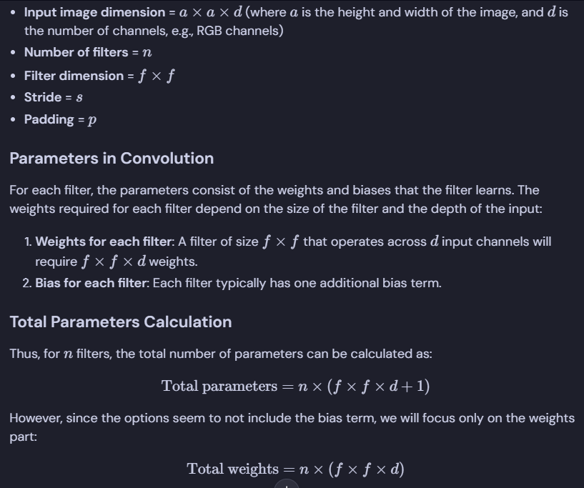 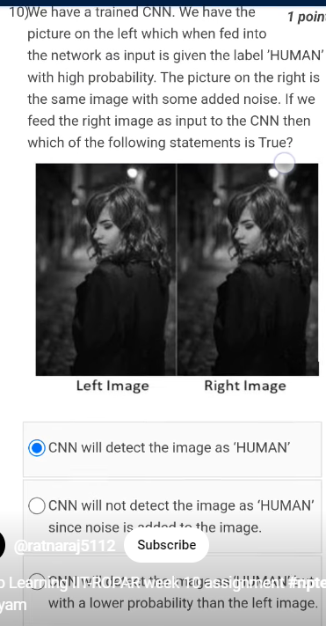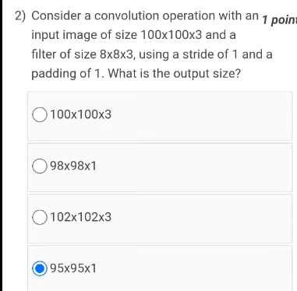 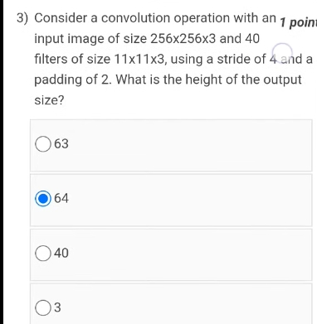 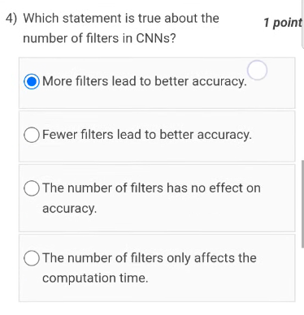 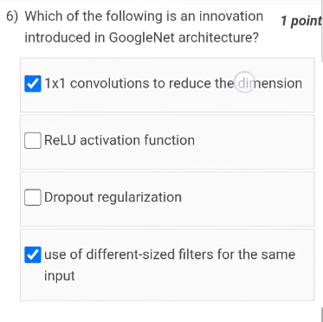 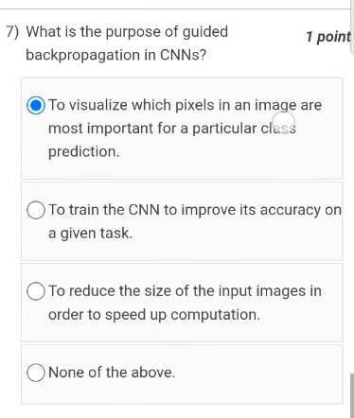

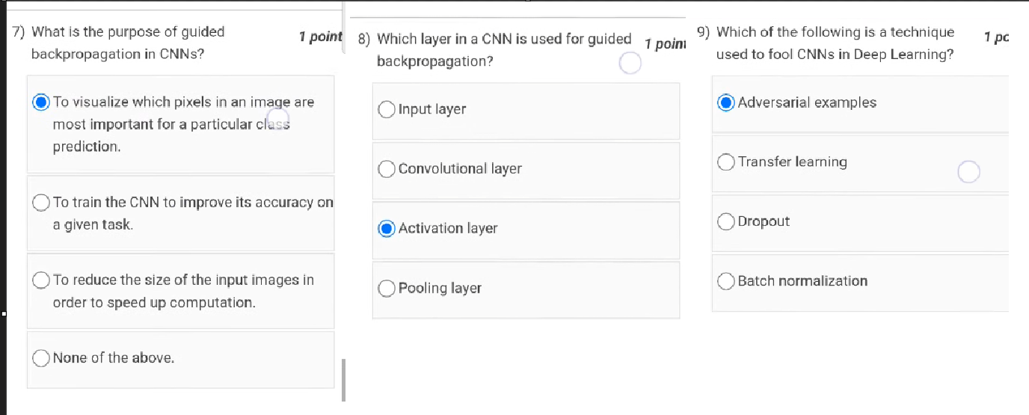

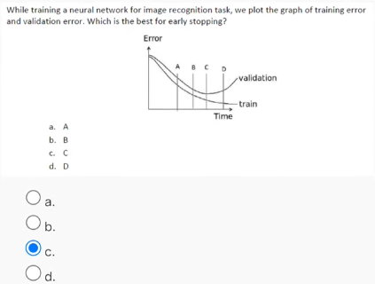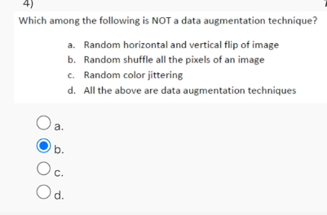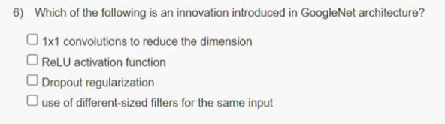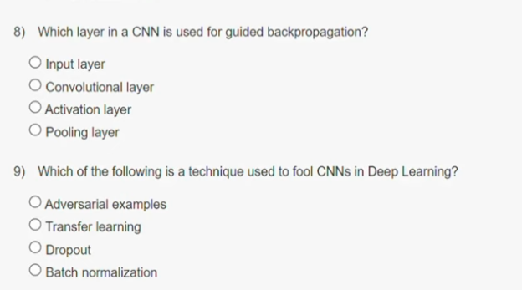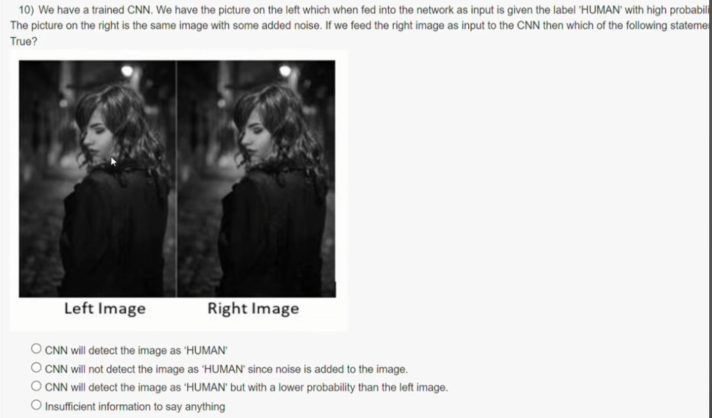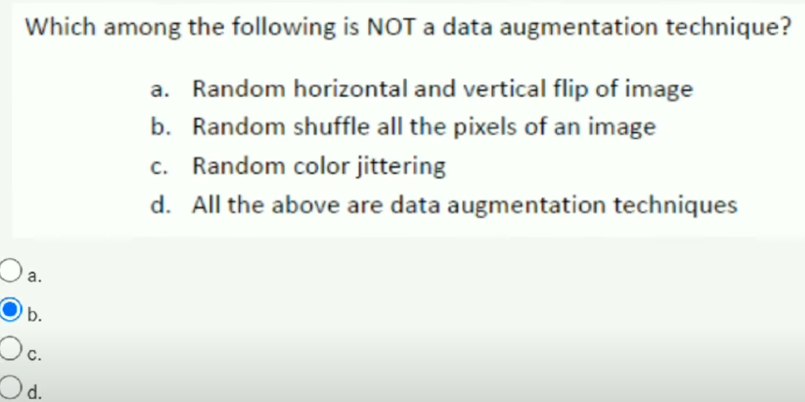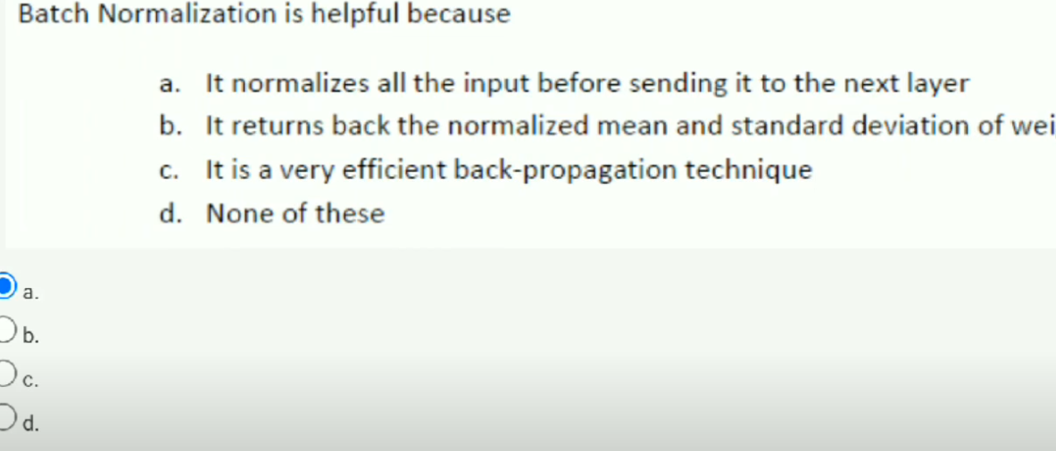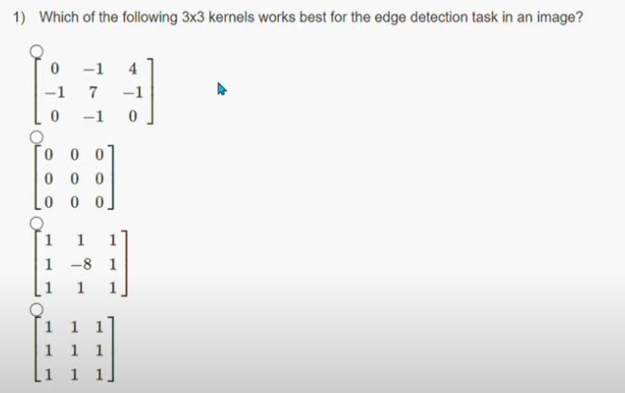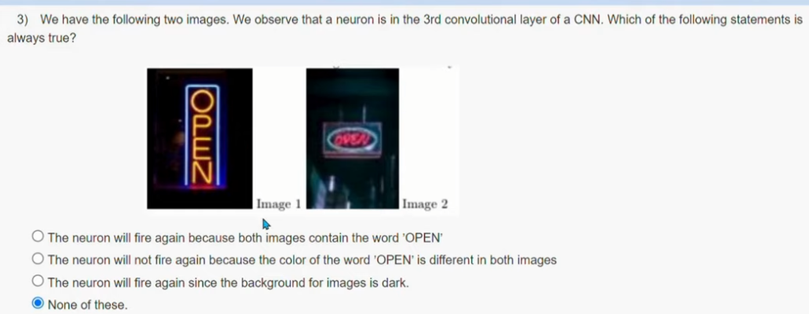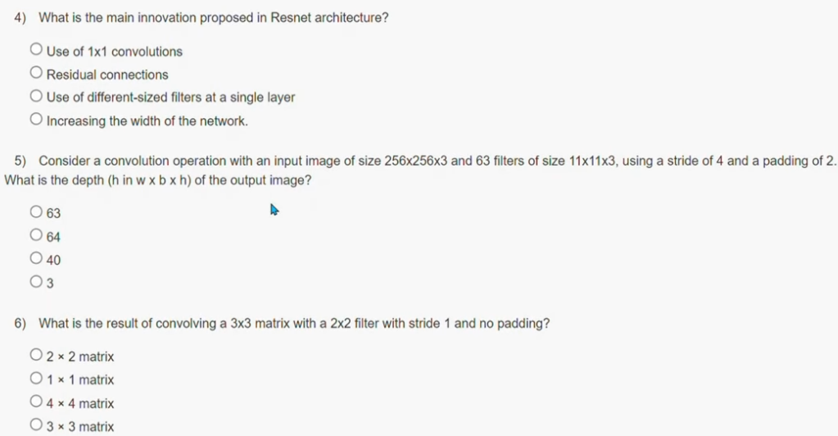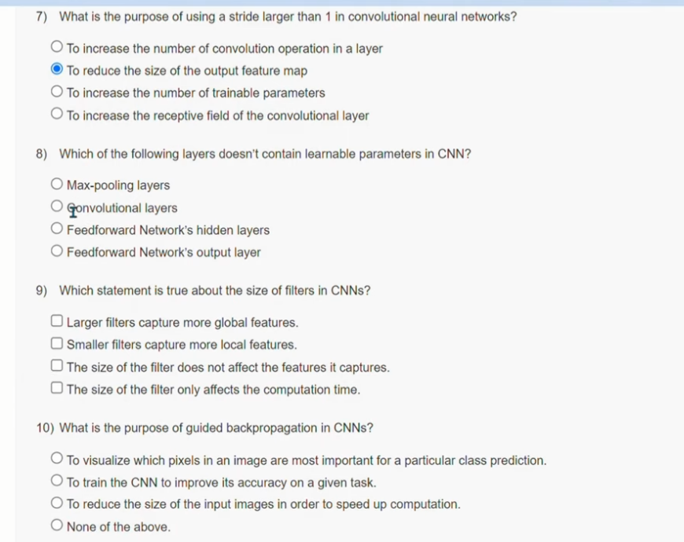

Here are the questions with options, followed by the answers:

---

**Question 1:**

What is the purpose of guided backpropagation in CNNs?

- **Options:**

1. To visualize which pixels in an image are most important for a prediction.

2. To train a CNN to be more accurate on specific types of images.

3. To speed up the training process of a CNN.

4. To reduce the number of parameters in a CNN.

5. None of the above.

- **Answer:** 1. **To visualize which pixels in an image are most important for a prediction.**

---

**Question 2:**

Which layer in a CNN is used for guided backpropagation?

- **Options:**

1. Input layer

2. Convolutional layer

3. Pooling layer

4. Fully connected layer

5. All of the above

- **Answer:** 2. **Convolutional layer**

---

**Question 3:**

Which of the following is a technique used to fool CNNs in Deep Learning?

- **Options:**

1. Adversarial examples

2. Transfer learning

3. Dropout

4. Batch normalization

5. None of the above

- **Answer:** 1. **Adversarial examples**

---

**Question 4:**

Which of the following is an innovation introduced in GoogleNet architecture?

- **Options:**

1. 1x1 convolutions to reduce the dimension

2. ReLU activation function

3. Dropout regularization

4. Use of different-sized filters for the same input

5. None of the above

- **Answer:** 1. **1x1 convolutions to reduce the dimension**

---

**Question 5:**

Which of the following is NOT a data augmentation technique?

- **Options:**

1. Random cropping

2. Random flipping

3. Random rotation

4. Random color jittering

5. All of the above are data augmentation techniques

- **Answer:** 5. **All of the above are data augmentation techniques**

---

**Question 6:**

Which of the following is the most important factor to consider when choosing a loss function?

- **Options:**

1. The type of data being used

2. The complexity of the model

3. The desired output format

4. The computational resources available

5. None of the above

- **Answer:** 1. **The type of data being used**

**Question 1:**  
Which of the following 3x3 kernels works best for the edge detection task in an image?

* **Options:**
  1. [0,−1,4],[−1,0,−1],[4,−1,0][0, -1, 4], [-1, 0, -1], [4, -1, 0][0,−1,4],[−1,0,−1],[4,−1,0]
  2. [0,0,0],[0,7,0],[0,0,0][0, 0, 0], [0, 7, 0], [0, 0, 0][0,0,0],[0,7,0],[0,0,0]
  3. [0,−1,0],[−1,8,−1],[0,−1,0][0, -1, 0], [-1, 8, -1], [0, -1, 0][0,−1,0],[−1,8,−1],[0,−1,0]
  4. [1,1,1],[1,1,1],[1,1,1][1, 1, 1], [1, 1, 1], [1, 1, 1][1,1,1],[1,1,1],[1,1,1]
  5. [1,1,1],[1,−8,1],[1,1,1][1, 1, 1], [1, -8, 1], [1, 1, 1][1,1,1],[1,−8,1],[1,1,1]
* **Answer:** 3. **[0,−1,0],[−1,8,−1],[0,−1,0][0, -1, 0], [-1, 8, -1], [0, -1, 0][0,−1,0],[−1,8,−1],[0,−1,0]**

**Question 2:**  
We have the same CNN. We have the picture on the left, which, when fed into the network as input, is given the label "HUMAN" with high probability. The picture on the right is the same image with some noise added to it. When fed as input to the CNN, which of the following statements is true?

* **Options:**
  1. CNN will detect the image as "HUMAN"
  2. CNN will detect the image as "NOT HUMAN"
  3. CNN will detect the image as "HUMAN" but with a lower probability than the left image
  4. CNN will not say anything
* **Answer:** 3. **CNN will detect the image as "HUMAN" but with a lower probability than the left image**

**Question 3:**  
Which among the following is NOT a data augmentation technique?

* **Options:**
  1. Random horizontal and vertical flip of the image
  2. Random shuffle all the pixels of an image
  3. Random color jittering
  4. All the above are data augmentation techniques
* **Answer:** 2. **Random shuffle all the pixels of an image**

**Question 4:**  
We have the following two images. We have trained a CNN for the 3rd convolutional layer of a CNN. Which of the following statements is always true?

* **Options:**
  1. The neuron will fire again because both images contain the word "OPEN"
  2. The neuron will not fire again because the color of the word "OPEN" is different in both images
  3. The neuron will fire again since the background for both images is different
  4. None of these
* **Answer:** 4. **None of these**